 Art Document

Document Issue: 1.0 Document Status: In Progress
Date Issued: Jan 09, 02 Filing Path:
Document Title: Simpson’s Character Animation Process
                - Author: Yayoi Maruno

Revision History
Issue | Date | Person | Reason - include problem #, ECN #, etc.
1.0 | Jan 03, 2002 | Yayoi Maruno | Initial draft of document taken from Jeff Harkness documentation, excerpts from Rustle Hill Art Pipeline and current pipeline process.

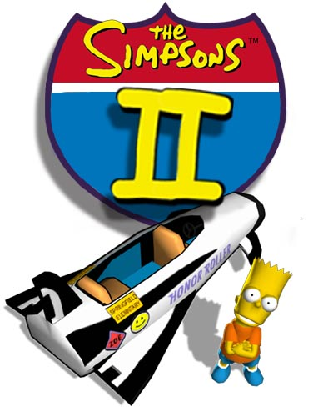

Table of Contents
1 DOCUMENT SUMMARY 3
1.1 DESCRIPTION 3
2 OVERVIEW 3
2.1 Character Animation 3
2.2 Character Animation Goals 3
2.3 Terminology 3
3 Character Animation Directory Structure 6
4 Character Animation Process 6
5 Character Animation Pipeline 7
5.1 Overview 7
5.2 Batcher Tool 7
6 CHARACTER SETUP 8

DOCUMENT SUMMARY

DESCRIPTION

This animation process document is intended to provide an initial framework to define the Simpson’s animation process.

This document will be updated when necessary as we continue to refine our technology, building process, game and evolve the animation process through trial and experimentation.

OVERVIEW

Character Animation

To develop a company wide (global) standardized streamline process of creating skeletons, building and applying animation.

Character Animation Goals

- Establish a game wide standard skeleton
- Create a streamline process for creating and iterating
- Globalizing the process as a standard within the company
- Create custom tools to speed efficiency of animation creation

Terminology

Standard Skeleton or Core Skeleton - A common group of bones and transforms across a group of skeletons made up of core joints

Secondary Joints – Are the remaining joints in each character specific skeleton that are sorted after the core joints.

Root Nodes – is a collection of Motion_Root, Orientation_Root, Character_Root and Extra_Attributes.

Motion_Root – is the name given to the top node in Maya. It is animated by the animator but animating only the simple major translation of the character on the X-Z plane. Its main purpose is for run time AI.

Orientation_Root – (Facing Vector) - the name given to a Child Node of the Motion_Root. It is animated by the animator but gets only Y rotation. This node has no dependents and can be animated last. Its purpose is for runtime AI and is to point in the direction the character is facing.

Character_Root – the first real joint in Maya. It controls the upper body and can be fully animated.

Extra_Attributes – A storage node for extra runtime data like foot placement information.

Pure3d Exporter Preferences– stores the exporter settings for a scene

Pure3d Joint Attributes – are joint specific attributes that define the scope and visibility of each joint to the exporter.

Skeleton_Root - is a Pure3d joint attribute. These joint specific attributes define the scope and visibility of each joint to the exporter.

Joint Sort Order – is a Pure3d joint attribute to define where the skeleton begins. The motion root would have this flag.

Traverse Stop – a Pure3d joint attribute to stop the exporter from exporting past a flagged joint in a hierarchy.

Preserve Bone Length – a Pure3d joint attribute that stops the exporter from exporting bone length animation for flagged joints.

Joint – in Maya it means a bone. To Pure3d it means a transform node (i.e. joint, null, locator or object)

Clips – a Maya file type that contains only the animation from a scene

Character Set – is a collection of channels used by the track editor which is used to import Clips

Master_Skeleton File – Per character is a collection of core joints and character specific secondary joints bound to a mesh that has no textures and has a Character Set established with the commo IK if used. The Pure3d Exporter Preferences are set to export animation and all Pure3d Joint Attributes are set as needed.

Master_Skeleton_Core File – is merely a derivative of the former with the Pure3d_Joint_Attribute, Traverse Stop set for all Secondary bones.

Master Model File – contains a collection of core joints and character specific secondary joints bound to the current mesh that has the current textures and the Pure3d Exporter Preferences set to not export the animations. The Character set posed in its bind pose. This is the master model, mesh, skeleton, textures to export to runtime. When it is complete the Master Skeleton is derived from it for the animators.

Character Animation Directory Structure
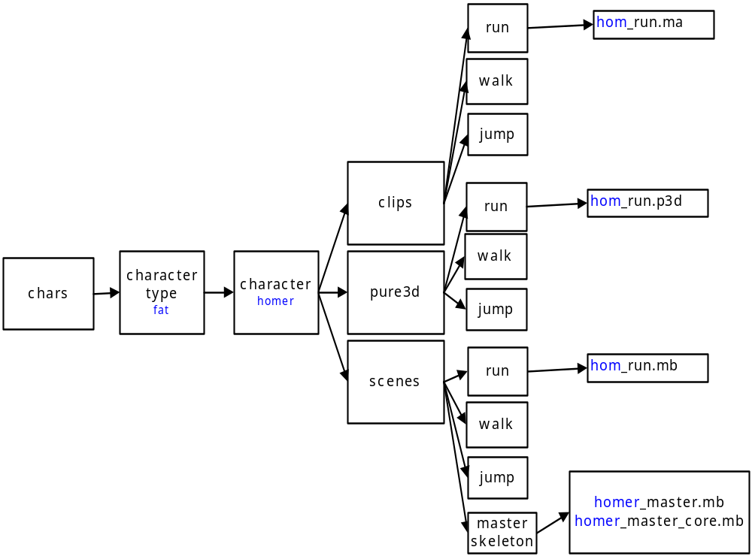

Character Animation Process
Step 1
Determine a core game skeleton for each characters in the game. The core skeleton consists of the joints in the character that will be hand animated and not controlled by physics or other means. The other joints that are controlled by physics or other means are secondary joints. When fitting the core skeleton into each character it is important to maintain the pivot orientation of the joints. It is important to standardize the naming of joints to reuse animation assets both in production and in game.

Step 2
Determine an animation tree that is an outline of all the animations that are used in the game for each character. First, map out animation sets of what the character will be doing in the game. I.e.: locomotion, defence, throwing… Next break down these animation sets into specific moves that are needed to achieve game play. I.e.: locomotion = idle, walk, run, sprint, turn 180: defence = idle crouch with ball, defend left, defend right, defend up, defend down… From this the total number of animations in the game can be determined by multiplying the number of animations for a single character by the number of characters. This may be reduced by animation sharing in game.

Step 3
Create a tool set to standardize the production of animations for ease of iteration and reuse in production. Set up an organization structure for production art assets and final in game exports. Develop a pipeline to export production animation into game format.

Step 4
Animate one or two characters animation trees to determine the game play experience and test. Then refine the animation tree if necessary and fine-tune the timing and posing of the animations. Once one or two characters have been finalized, the rest of the characters can be animated with the tested refined animation tree that now contains timing and basic posing to speed up the production of the final characters animations that are needed.

Character Animation Pipeline

Overview

The animation pipeline is the process by which animations get made and exported into the game. The pipeline has been designed to allow the flexibility for change while minimalizing work loss. This is achieved by standardizing the game skeleton and using Mayas character creation and animation clip functionality in conjunction with the Batcher tool. At a micro level an animation can be created and transfer to other “like” character and iterated instead of reanimated. At a macro level the game skeleton can be changed and all the animations that have been created for that skeleton can be retarget to work for the new skeleton. This can be done in a batch process that will change all the animations at once.
Each skeleton is standardized with a “core” skeleton that is the same in each character. The pivots of each joint, the naming of joints, parenting order and the bind pose is the same for each character. The difference between each character is there proportions (joint lengths). Each character can have different secondary joints that are either controlled by in game physics or hand animated separately.

Batcher Tool

The batcher tool has a number of functions that improves work flow for animators and increase productivity during production. All of the functions listed can be batch processed so that a number of files can be processed at once.

Character and clip creation: Animations that have been completed can easily be converted into clips, to be used on other characters, and saved. This allows a clean file to be saved for ease of the iteration,while having a transferable copy of the animation that can be easily updated.

Mirroring: Animations that have a directional requirement (ie: step left) can be mirrored so that one animation can be used to create both directions.

Applying custom maps: Animation offset maps can be made to either change the look of animations or if changes have been made to the game skeleton. All the existing animations can then be processed with this map so that no animation is lost.

Remapping: A remapping script can be written which contains offsets to compensate for proportion differences so that animations transferred from one character to another is more exact and less iteration is needed.

Scene to scene transfer: This allows for specialized animations rigs to be used to animate certain moves and then transfer both the rigs and animation to other characters in scene form for ease of iteration.

Exporting: Exporting animations from one master skeleton to insure that all the settings are the same and minimize errors.

All these functions can be used in combination with each other to further increase production performance. (ie: an animation can have a custom map applied to it, then mirrored and a mirrored clip saved out and have both exported for game use)

CHARACTER SETUP

- The scale of the simpsons game is Meters. Check and make sure before you export.
- The P3D attributes for the skeleton need to be set before export.
- They are found in the “attribute editor” under “Extra Attributes”
- They should be:
- “P3d Skeleton Root” is to be set on the top node of the characters hirarchy.
- “P3d Preserve Bone Length” is to be set one all of the joints on the character.
- Currently the sort order of the Hair joints is left set to 0.

All meshes need to be explicitly named.
All of the Meshes are combined into one by the exporter.
The first mesh parented under the Groupnode is where the name of the combined mesh comes from. It should follow one naming convention.

